Definition :-

A standard form of communication for transferring electronic health information

between various clinical information system.

What is HL7 ?

Established in 1987, Health Level Seven(HL7) is an ANSI accredited, not-for-profit standards-development organization, whose mission is to provide standards for the exchange, integration, sharing and retrieval of electronic health information; support clinical practice; and support the management, delivery, and evaluation of services.

HL7 offers a standard for data exchanging among healthcare application, thus enabling communications in healthcare settings.

Why HL 7 ?

If there are 3 peoples from other countries one from India, second from China and third from USA. All of them having their different mother tongue. So, no one can understand their languages, or suppose there are 10 peoples from other countries no one understand the other languages. For to interaction, they need to learn other languages and then interact with them. So, they thought come up with the common language which would be the only language we have to learn and using that language go ahead converse between each other. So at the end of the day, we don’t need learn many other languages but only one.

What is an Interface ?

An interface is nothing but a bridge using which we will be sending data from one system to another system.

We are making PM to talk with EHR with the help of exchanging data but apparently, we are going to exchange the data from the database. We are going to extract the data from the database converted to HL 7 and send it over to the destination side.

General Terms :-

* PM – Practice Management
* EHR – Electronic Health Record
* HIS – Hospital Information System
* LIS – Lab Information System
* RIS – Radiology Information System
* ICD – International Classification of Diseases
* CPT – Current Procedural Terminology
* CCD – Continuity of Care Document
* HIE – Health Information Exchange
* IHE – Integrating Health Enterprise

Message Types :-

* ADT(Admission, Discharge, and transfer) – Patient Administration
* ORM(General Order Message) – Orders
* ORU(Observation Reporting) – Results
* MDM(Medical Document Management)
* DFT(Detailed Financial Transactions)
* BAR(Billing Account Record)
* SIU(Scheduling Information Unsolicited)
* RDS(Pharmacy/treatment Dispense)
* RDE(Pharmacy/treatment Encoded Order)
* ACK(Acknowledgement Message)

Why the name HL7?

It come up with the 7 layers which follows the OSI Model (Open System Interconnections Model).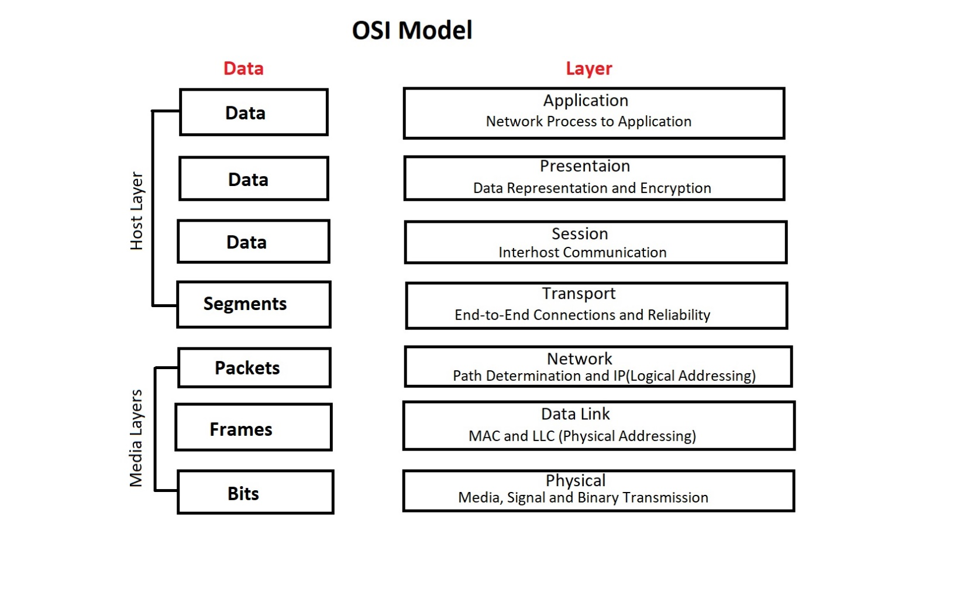

HL7 and FHIR :-

* Many people thinks that HL7 is replaced by FHIR but is not a replacement.
* Reason is that HL7 is event based messaging methodology, meaning an event happens in this system then and then HL7 message will get generated.
* Where the FHIR is a resource-based system or resource-based technology where resources will be used to give access to some other third-party application.
* So, both are different verticals all together.
* HL7 is used to exchange data between two different systems in the real time when something happens with the front-end or the clinical system.
* Whereas FHIR is used to integrate other third-party devices with the hospital system.

Advantages of HL7 :-

* Ability to share medical, demographic and billing data with HL7 enabled application.
* Data transfer in the form of messages.
* No special tool required for creating messages.
* Code in ASCII is ‘Human Readable’.
* Can work on any OS.
* And it will work any system to any system.
* HL7 assists access to the overseas market.(It will enable us to communicate between country-country and state-state.)

Why do we need standards?

* Sharing of medical data
* Accessibility to a large subset of data
* Quicker insurance claims payments
* Interoperability – ‘Apps talk to each other’
* Greater safety for the patient
* Quality, Quality, Quality

Anatomy of Messages:-

* Message
  + - Segment
      * + Field

Component

Subcomponent

**Message Delimiters**

|  |  |  |  |
| --- | --- | --- | --- |
| Delimiter | Suggested Value | Encoding Character position | Usage |
| Segment Terminator | <cr>  hex 0D | - | Terminate a segment record. |
| Field Separator | | | - | Separates two adjacent data field within a segment. |
| Component Separator | ^ | 1 | Separates adjacent component of data field where allowed. |
| Subcomponent Separator | & | 4 | Separates adjacent subcomponents of data fields where allowed. |
| Repetition Separator | ~ | 2 | Separates multiple occurrences of a field where allowed. |
| Escape Character | \ | 3 | Escape character for use with any field represented by an ST, TX or FT data type, or for use with the data component of the ED data type |
| Truncation | # | - | “#” denotes that the value of the field may be truncated. This character should be used at the end of the truncated value to indicate it was truncated. |

Modes of communication involve two types processing:

* Batch Processing :-
  + - One or more messages can be transferred through batch files to be sent in a single file.
    - Batch processing is useful for systems that are not connected via real-time transmission protocols.
* Real Time Processing :-
  + - Message are transferred in real-time between systems.

Where does HL7 operates?

|  |  |
| --- | --- |
| * Patient Administration | * Master files and indexes |
| * Order Entity | * Medical Records / Information Management |
| * Financial Management | * Scheduling and Logistics |
| * Observation Reporting | * Patient Care |

How HL7 messaging works Trigger Events?

Trigger event is nothing but a real-time event which is generating a necessity of data flow from PM system to EHR system.

Rules for trigger events:

* Each trigger event is associated with only one message type.(ex. ADT)
* A message type may have multiple trigger events associated with it.(ex. A01, A02, A03…)

**ADT Message Event**

|  |  |
| --- | --- |
| A01 | Admit Patient |
| A02 | Transfer Patient |
| A03 | Discharge Patient |
| A04 | Registration Patient |
| A05 | Pre-Admit Patient |
| A08 | Update patient information |
| A11 | Cancel Admit of Patient |
| A12 | Cancel Transfer of Patient |
| A13 | Cancel Discharge of Patient |

Models of data flow for HL7:

* Declarative Model: Unsolicited update/ acknowledgement
* Interrogative Model: Query/Response
* Query /Response is used for collecting
  + - Data regarding a single patient.
    - Data regarding a multiple patient.
    - Data that is not patient related.
* Unsolicited update / acknowledgement
  + - When transfer of information is initiated by the application system that deals with the triggering event
    - For ex. ADT/ACK – admit/visit notification.
      * Nursing system that the patient has been admitted and needs a care plan prepared.
      * Pharmacy system that the patient has been admitted and will need drugs to be described.
      * Finance system for starting a billing period for that admitted patient.
      * Dietary system that the patient has been admitted and requires dietary services.

Message Construction Rules:-

* First thing to know about HL7 is comprised of messages that contains segments and segments contains components and components contain the actual data. And there is also a subcomponent that contains a data in filed.
* Fields are separated by pipes which is having two purposes.

1. Tell the interface, how to parse out the data.
2. Provides us a way to easily read the messages.

MSH – Message Segment Header

MHS|^~\&|SEM||PYX||20040301192350||ADT^A04|ADT757452230|P|2.3||||||||

1 2 3 4 5 6 7 8 9 10 11 12….

|  |  |
| --- | --- |
| Sequence | Element Name |
| 1 | Field Separator |
| 2 | Encoding Character |
| 3 | Sending Application/web application name |
| 4 | Sending Facility/hospital name |
| 5 | Receiving Application/lab application |
| 6 | Receiving Facility/lab name |
| 7 | Date/Time of Message |
| 8 | Security |
| 9 | Message Type/trigger event |
| 10 | Message Control ID/unique id assign to each msg |
| 11 | Processing ID & hint/flag msg exchanged P,D,T |
| 12 | Version ID |
| 13 | Sequence Number |
| 14 | Separation Pointer |
| 15 | Accept Acknowledgement Type |
| 16 | Application Acknowledgement Type |
| 17 | Country Code |
| 18 | Character Set |
| 19 | Principal Language |

|  |  |
| --- | --- |
| Value | Processing ID |
| D | Debugging |
| P | Production |
| T | Training |

Abstract Message Syntax :-

MSH 1 is always pipe.

* The abstract message is the pattern of segments associated with a trigger event.
* A definition table that indicates the usage of all segments that may appear in the message legally in the HL7 standard message.
* Reading the Syntax :-
  + - [] -> It is indicating that the enclosed group of segments is optional.
    - {} -> It is Indicating that one or more repetitions of the enclosed group of segments.
* Example :-
  + - - MSH MSA [ERR]
    - - MSH PID PV1 {[ORC]{OBX}}

What is Segment? :- Each line in HL7 message is known as Segment.

Use of Escape Sequence :-

* The most common use of HL7 Escape Sequences is to escape the HL7 defined delimiter character.
* These sequences begin and end with the message’s escape character.

|  |  |
| --- | --- |
| Escape Character | Usage |
| \F\ | Sends the field separator |
| \S\ | Sends the component separator |
| \T\ | Sends the subcomponent separator |
| \R\ | Sends the repetition separator |
| \E\ | Sends the escape character |
| \H\ | Start highlighting |
| \N\ | Normal text(end highlighting) |
| \L\ | Sends the truncation character |

Version Compatibility Definition :-

* HL7 standard may introduce new messages in each succeeding version.
* In each succeeding version, the standard may add new fields at the end of a segment, new components at the end of a field and new subcomponent at the end of a component and a non-repeating field may be made repeating.
* If version 2.3 received message from new version 2.7, in new version some new fields are added. If new parts of field are ignored in version 2.3. What remains is the old field, which has the same meaning as it had in the prior version of HL7.

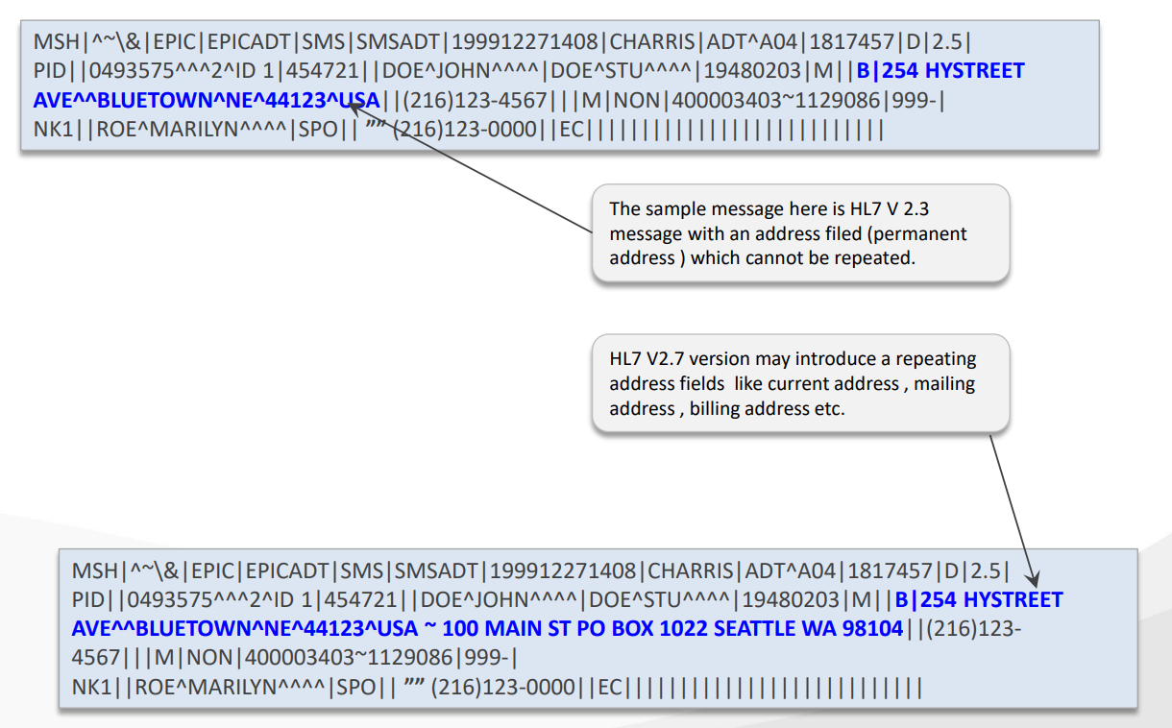

Acknowledgement Messages :-

* Receiver informs the sender whether the message was received and processed successfully.
* Acknowledgements are broadly of 2 types:-
  + - Original Mode ACK: point to point setting

When the unsolicited update is sent from one system to another, this acknowledgement mode specifies that it be acknowledged at the application level.

* + - Enhanced Mode ACK: network setting
      1. Receiving system may send back an immediate accept acknowledgement indicating whether it was able to receive and take custody of the message, without respect to the status of further processing.
      2. Later, the receiving application may send back an application acknowledgement indicating whether the message could be processed.

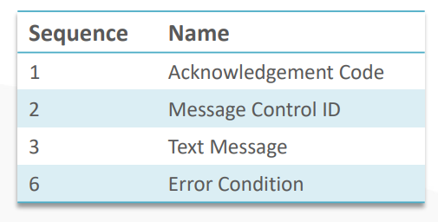

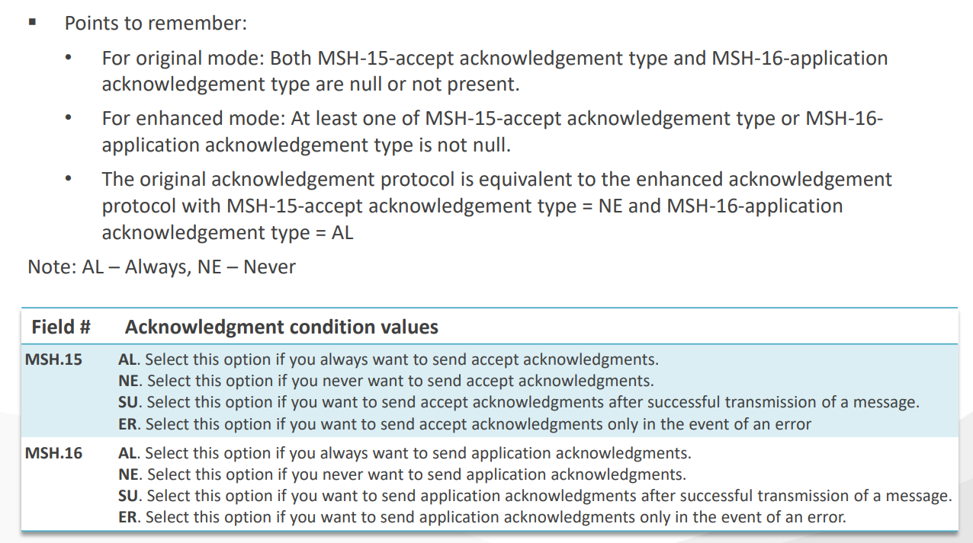

Message Control Segments:-

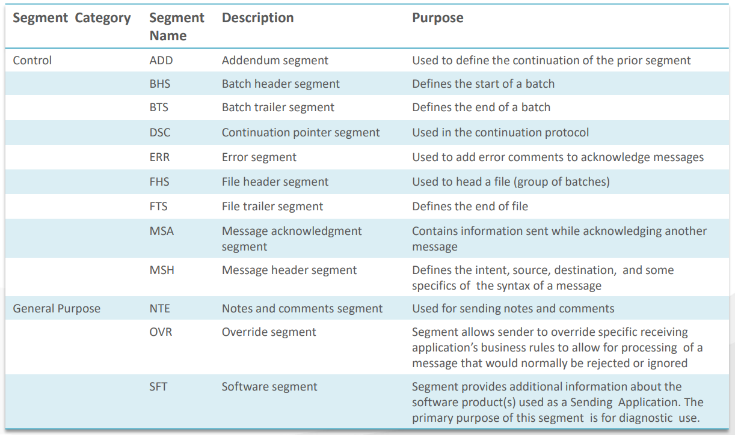

**Segments**

|  |  |  |  |  |  |
| --- | --- | --- | --- | --- | --- |
| ADT | | ORM | | ORU | |
| MSH | Message Header | MSH | Message Header | MSH | Message Header |
| EVN | Event Type | PID | Patient Identification | PID | Patient Identification |
| PID | Patient Identification | PD1 | Patient Additional Demographics | PV1 | Patient Visit |
| NK1 | Next Of Kin | OBR | Observation Request |
| PV1 | Patient Visit | PV1 | Patient Visit | OBX | Observation Segment |
| PV2 | Patient Visit Additional Info. | ORC | Common Order | CT | Clinical Trial Identification |
| OBX | Observation/ Result | OBR | Observation Request |  |  |
| AL1 | Allergy Information | DG1 | Diagnosis |  |  |
| DG1 | Diagnosis Information |  |  |  |  |
| PR1 | Procedures |  |  |  |  |
| ROL | Role |  |  |  |  |
| GT1 | Guarantor Information |  |  |  |  |
| IN1 | Insurance Information |  |  |  |  |

HL7 Message Types:-

ADT (Admit, Discharge and transfer) –

ADT messages are one of the most widely used and high volume HL7 message types, it provides information for many triggers events including patient admissions, registrations, cancellations, updates, discharges, patient data merges, etc.

ORM (Order Entry) –

The HL7 Order Entry (ORM) message is a commonly used message type that holds information about a request for materials or services.

Mostly used for patient specific orders. ORM messages are most commonly used to facilitate orders and results workflows within Radiology and Laboratory departments.

The ORM message only has one type : ORM^O01

ORU (Observation Result) –

An HL7 Observation Result (ORU) message contains information about a patient’s clinical observations and is used in response to an order generated in a clinical system (HL7 ORM message).

ORU messages are most commonly used within the context of laboratory results, imaging studies, and clinical interpretations.

It has also been used to communicate order and results information for the purpose of clinical trials.

ORU message has only two different types:

* **ORU^R01 – Unsolicited transmission of an observation results.**

This message is generated when results from the receiving (results) system need to be communicated to the sending system.

* **ORU^W01 – Waveform result, unsolicited transmission of requested information**

This message type transmits waveform data (e.g., produced from electrocardiograms) produced by an ordered test or multiple observations.

**Fields in the Segments:-**

1. PID –

|  |  |  |
| --- | --- | --- |
| **SEQ** | **OPT** | **Field Name** |
| 1 | O | Patient ID |
| 2 | O | Patient ID (External ID) |
| 3 | R | Patient ID (Internal ID) |
| 4 | O | Alternate Patient ID – PID |
| 5 | R | Patient Name |
| 6 | O | Mother’s Maiden Name |
| 7 | O | DOB |
| 8 | O | Sex |
| 9 | O | Patient Alias |
| 10 | O | Race |
| 11 | O | Patient Address |
| 12 | O | Country Code |
| 13 | O | Phone Number – Home |
| 14 | B | Phone Number – Business |
| 15 | O | Primary Language |
| 16 | O | Marital Status |
| 17 | O | Religion |
| 18 | O | Patient Account Number |
| 19 | O | SSN Number – Patient |
| 20 | O | Driver’s License Number – Patient |
| 21 | O | Mother’s Identifier |
| 22 | O | Ethnic Group |
| 23 | O | Birthplace |
| 24 | O | Multiple Birth Indicator |
| 25 | O | Birth Order |
| 26 | O | Citizenship |
| 27 | O | Veterans Military Status |
| 28 | O | Nationality |
| 29 | O | Patient Death Date and Time |
| 30 | O | Patient Death Indicator |

1. EVN – The EVN is used to communicate trigger event information to receiving application.

|  |  |  |
| --- | --- | --- |
| **SEQ** | **OPT** | **Field Name** |
| 1 | B | Event Type Code |
| 2 | R | Recorded Date/Time |
| 3 | O | Date/Time Planned Event |
| 4 | O | Event Reason Code |
| 5 | O | Operator ID |
| 6 | O | Event Occurred |

1. IN1 – This segment contains insurance policy coverage necessary information.

|  |  |  |  |  |  |
| --- | --- | --- | --- | --- | --- |
| **SEQ** | **OPT** | **Field Name** | **SEQ** | **OPT** | **Field Name** |
| 1 |  |  | 25 |  |  |
| 2 |  |  | 26 |  |  |
| 3 |  |  | 27 |  |  |
| 4 |  |  | 28 |  |  |
| 5 |  |  | 29 |  |  |
| 6 |  |  | 30 |  |  |
| 7 |  |  | 31 |  |  |
| 8 |  |  | 32 |  |  |
| 9 |  |  | 33 |  |  |
| 10 |  |  | 34 |  |  |
| 11 |  |  | 35 |  |  |
| 12 |  |  | 36 |  |  |
| 13 |  |  | 37 |  |  |
| 14 |  |  | 38 |  |  |
| 15 |  |  | 39 |  |  |
| 16 |  |  | 40 |  |  |
| 17 |  |  | 41 |  |  |
| 18 |  |  | 42 |  |  |
| 19 |  |  | 43 |  |  |
| 20 |  |  | 45 |  |  |
| 21 |  |  | 46 |  |  |
| 22 |  |  | 47 |  |  |
| 23 |  |  | 48 |  |  |
| 24 |  |  | 49 |  |  |

REQUIRED | IMPORTANT

NPI LookUP.com

ORC is always be first and OBR is always followed by ORC. First ORC will there then only OBR will be there. In entire ORM message there can’t be multiple ORC.

`Few Basic Fields we need:-

MSH 3,4,5,6,7,9,10

PID 1,2,3,4,5,7,11,18,19,13,14

PV1 3,2,7,8,9,44,45

OBR 1,2,3,4(Test type),7,8,15,16,24

ORC 1,2,5,12

OBX 1,2,5,3,4,6,7,11,(In entire message OBX can one or multiple)

Trigger Events

ADT^A01,A02,A03,A04,A08,A28,A34

ORM^O01

ORU^R01,R03

How do I pass null if filed?

MSH|||||||||””|

What is empty filed?

When we don’t write in filed like MSG|||||||||||.

But when we want to explicitly send a null value then MSH|||||||||””|.